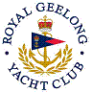 | Royal Geelong Yacht Club Inc.  Est 1859
Trophy Deed of Gift.

Trophy: | Kevin Bell Memorial Trophy
Presented by: | The Family of Kevin Bell
Date: | 18th day of March, 2019
For: | Three nominated Keel Boat, Summer Aggregate, Club Outer Harbour Races
Remarks / Revisions
Click HERE for a list of Recipients.

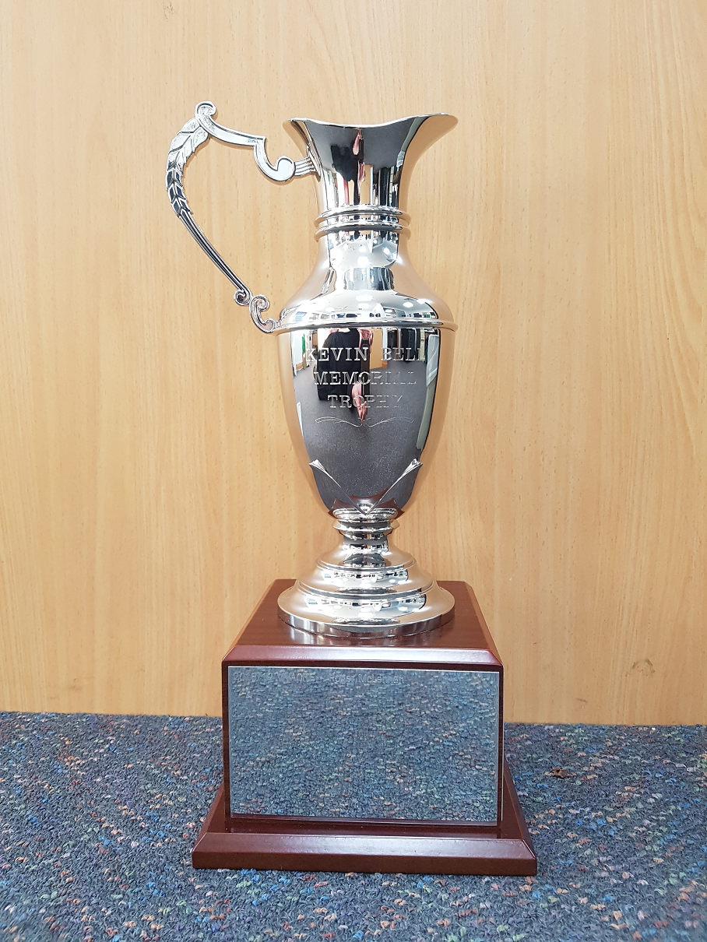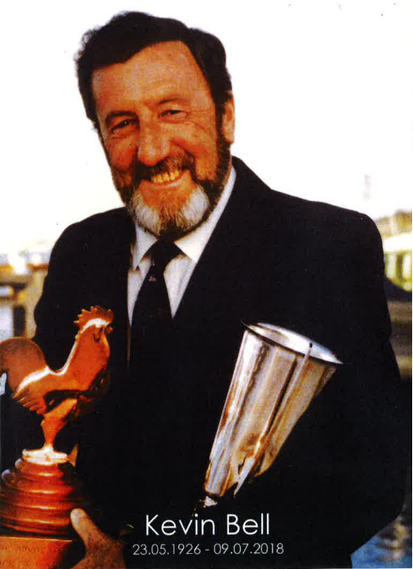

DEED OF GIFT AND THE CONDITIONS GOVERNING THE Kevin Bell MEMORIAL TROPHY
This deed of gift made this 18th day of March, 2019, by the family of Kevin Bell,
WHEREAS, the family wish to honour the memory of Kevin Bell, well known to all at Royal Geelong Yacht Club (RGYC).
This, Memorial Trophy is to enhance the spirit of friendly rivalry and camaraderie among the members of RGYC.
The "Kevin Bell MEMORIAL TROPHY” is subject to the following conditions:
- That any skipper participating in three RGYC Keel Boat, Summer Aggregate, Club Outer Harbour Races is eligible for the award;
- That the said trophy shall be permanently displayed in perpetuity in a suitable area of the clubhouse;
- That the said trophy shall be awarded only once during any sailing calendar year;
- That the overall winner of the three nominated Club Courses, shall be the recipient of the award of said trophy;
- Overall calculation to determine the winner will be based on best corrected time therefore all boats must race the same course(s) throughout the club series;
- That the Kevin Bell Memorial Trophy consist of the three races nominated by the Sailing and Boating Committee prior to season commencement, of which no less than two races will be considered for the eventual recipient, and be conducted in accordance with the Racing Rules of Sailing.
- That the said trophy shall never under any circumstances be transferred to any individual, club, or association, and shall remain the property of the RGYC in perpetuity;
- That the Commodore, or his appointed officer, shall announce the name of the recipient and shall present the trophy at a suitable ceremony upon conclusion of the summer aggregate series in any given year;
- That the designation of the names of the recipient of the award of the trophy shall be made by a small plaque containing the name of the winner, the year, and the name of the winning yacht as provided for on said trophy.
- That an individual suitable trophy containing the name of the winner, the year and the name of the winning yacht may be awarded to the winner.

